**Game Plan**

Ray Bike Supreme

**Game Description**

The game starts with a main landing page where the players can find the game play instructions, enter their name and select the game difficulty before pressing the start game button. When the game starts, the two players will control their bikes using the keyboard buttons (asdw for player one and up-down-left-right for player two). The goal of the game is to use the trail that each of the bikes leaves behind to trap the other player and force that player to run into it. The score earned by the winner will be the number of seconds the game lasted. When the game is over, the players can see their highest score so far and their accumulated score from the game over page. From that page, the players can choose to play again or return to the main menu.

**Screen by Screen Description of the UI**

HTML Elements:

title h1 element

help button element

“Player” p element

name input elements

bike image elements

“Difficulty” p element

Difficulty selection Nav bar element

Start game button element

HTML Elements:

Modal div element

Close screen button element

Instruction p elements

HTML Elements:

“Player” text p elements

Player name p elements

Score p elements

Arena div elements

Bike image elements

Rays canvas elements

Rock image elements

HTML Elements:

Modal elements

Text and score stats p elements

Play again button element

Return to Menu button elements

**Breakdown of Functional Components**

Main screen

- Player name input section

- difficulty selection menu

- Help/Instruction button

- Start game button

Instruction screen

- game play instruction text

- exist screen button

Game screen

- Scoreboard

- Gameplay arena

Game over screen

- current game score

- accumulated game score

- return to main screen button (erases accumulated score)

- play again button

**Gameplay logic flow chart:**

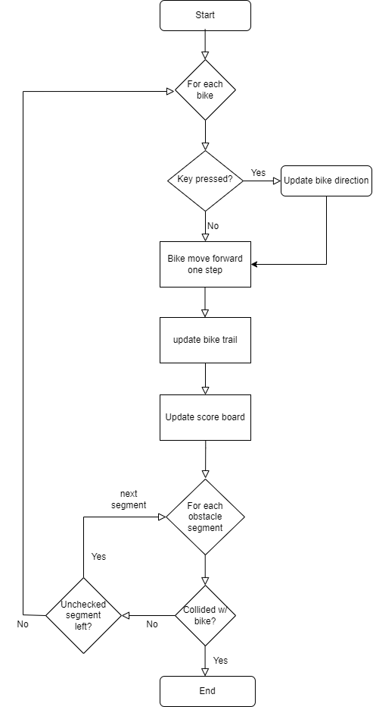

**Glossary of Class, Constants, Variables and Methods:**

class Game {

//constants

_SEGLENGTH :number //intrinsic segment length of the game

_RAYWIDTH :number //width of bike ray

_BIKESPEED :number //number of pixel advance per game logic loop

_ARENA_WIDTH :number //pixel width of gameplay arena

_ARENA_HEIGHT :number //pixel height of gameplay arena

_ARENA_CEN_POS :number //[left, top] of arena’s center

_GAME_START_TIME :Date //Datetime object of the game start time

_MIN_OBS_HEIGHT :number //min pixel height of rocks in medium difficulty mode

_MAX_OBS_HEIGHT :number //max pixel height of rock in medium difficulty mode

_OBS_IMG_PATH :string //path of the rock image

_BIKE_IMG_PATH :string //path of bike image

//variables

_difficulty :number //1 to 3 for easy to hard game mode, respectively

**_**score:number // track score of the game

**_**obsSegments :number [][] //array of obstacles segments, each segment is an array [x1,

y1, x2, y2]

_trailCanvases: HTMLElement //list of canvases html elements used to draw bike trails

_arena: HTMLElement //html element of the gameplay arena

_bikes: Bike[] //list of Bike objects

//methods

_setupArena() //create div element with appropriate css tags then add to DOM

_setupScoreBoard() //create div element with appropriate css tags then add to DOM

_setupCanvases() //create canvases elements in DOM and also add them to

_trailCanvases variable

_createBikes() //add bike images DOM with appropriate position and create

Bike object and added to _bikes list

_addObstacles() //randomly places obstacles (rock) on arena by appending rock

images element to arena elements, also add image

boundaries to _obsSegment array

_checkImgOverlap() //return Boolean of weather two obstacles(rock) image overlaps

_evolveGame() //initiate game logic loop with a indefinitely while loop

_incrementScore() //increment score board score

_draw_Trail() //draw or redraw bike trails

}

Class Bike {

//constants

_DIR_ARRAY :string[] //array of directions ordered by how it evolves as as user hits the

right key

_BikeRotation :enum //enum relating bike direction and degrees of image rotation

//variables

_arena :HTMLElement //arena html element

_bikeElement :HTMLELEMENT //img html element of the bike

_imgPosition :number[] //[left,top] of img when it's first loaded

_imgWidth :number //img width when it's first loaded

_imgHeight :number //img height when it's first loaded

_kbControl :string[] //an array [up,down,left,right] keyboard control key of bike

_headPosition :number[] //[x,y] position of bike's head

_centerPosition :number[] //[x,y] position of bike's center

_tailPosition :number[] //[x,y] position of bike's tail

_direction :string //current direction of bike's motion

_speed :number //num pixel bike moves per game interation

_bikeId :string //id field of bike's img html element

_centerSeg :number[] //[x_old, y_old, x_new, y_new],evolution of bike center position

during last interation

_trail :number[][] // a list of [x1,y1,x2,y2] segments the bike has travelled over

_trailColor :string //color of the trail

_cttSegNum :number //number of segments needed to span from bike center to bike tail

//methods

_getHeadPosition() :number[] //get list [x,y] of bike’s head position

_getCenterPostion() :number[] //get list [x,y] of bike’s center position

_getTailPosition() :number[] //get list [x,y] of bike’s tail position

_calculateHeadPosition() :number[] //get list [x,y] of head position base on current image

placement

_calculateCenterPosition() :number[] //get list [x,y] of center position base on current image

placement

_calculateTailPosition() :number[] //get list [x,y] of tail position base on current image

placement

_getImgPosition() :number[] //get list [left,top] of the bike image on the page

_updateDirection() //update bike direction and image placement base on key

pressed

_getNewDirection() :str //determine new direction using DIR_ARRAY

getTrail() :number[][] //get list of [x1,y1,x2,y2] of trail segments left behind by

the bike

getTrailColor() :str //getter method for trail color

moveForward() //advance bike’s motion along its current direction

hasCollided(obsSegment:number[][]):bool //determine if a bike has collided with the list of

obstacles segments

}